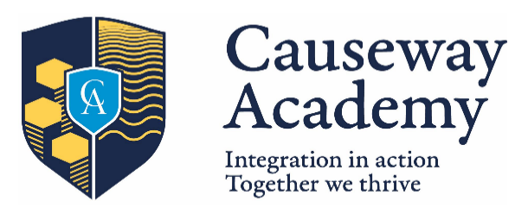
Post 16 Options September 2026

Block 1 | Block 2 | Block 3 | Block 4
Applied Science (Single Award)  Business Studies  Drama and Theatre  Construction (NRC)  Moving Image Art | Art  Children’s Play, Learning and Development  English Literature  ICT  Sport | Applied Science (Double Award)  Media  Travel and Tourism (Single Award)  Sociology | Health & Social Care  History  Travel and Tourism (Double Award)  Uniformed Protective Services
The basic entry requirement for Post-16 study is 5 GCSE’s at grades A*-C including either GCSE Maths or GCSE English Language.
It is recommended that all pupils study 3 A levels, although 2 or 4 A levels may be allowed in exceptional circumstances and at the discretion of the school.
Please circle your choices (only 1 per box, recommended maximum of 3). Subjects will only run if there are enough pupils to make the course viable.

Expression of interest
If you are interested in subjects which are not currently offered, please list them below. Please note that expression of interest is NOT a guarantee that it will be offered: as above, subjects will only run if there are enough pupils to make the course viable.

